Corporate Plan 2019-23 Performance Monitoring Report
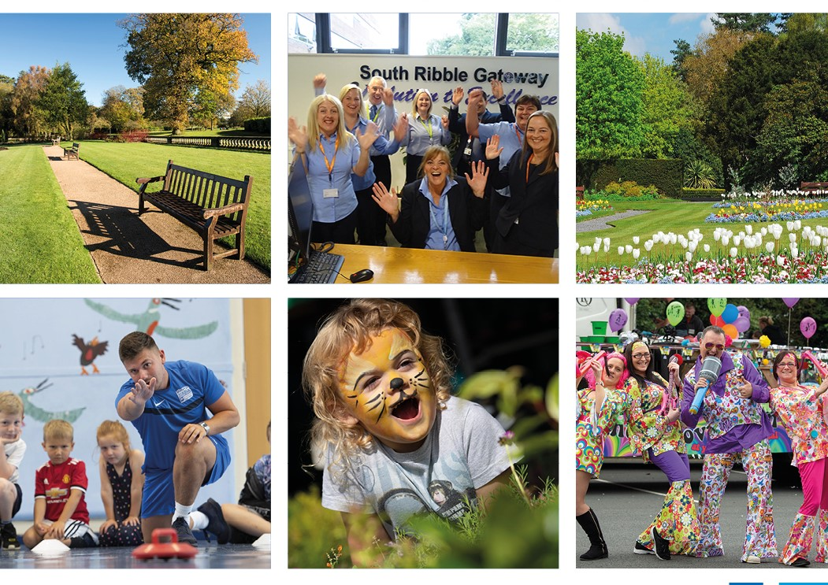

Reporting Period 1. 2019-20

Contents | Pg.
Report Structure | 2
Excellence, Investment & Financial Sustainability | 3
Health, Wellbeing and Safety | 6
Our People & Communities | 11
Place, Home and Environment | 15

Performance Key
Symbol | Determination
 | If we are doing well then it is Succeeding. Where a project or task has been achieved ahead of the due date set or a measure has achieved beyond its target.
 | It is On-track where a project or task will be delivered on the due date set or a measure is within its agreed targets
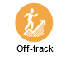 | It is Off-track where a project or task has not met its required due dates or a measure has not met its targets

Report Structure
This report forms part of the appendices of the “Performance Monitoring Report” update to the Scrutiny Budget and Performance Panel and Cabinet for reporting Period 1 of the Corporate Plan 2019-23, (October 2019 – December 2019). Cross references are made with the Period 1 Performance Monitoring Report to refer to sections containing more detail within this document.
This report reflects the Corporate Plan structure as approved September 2019 and is broken down into four sections (Outcomes):
- Excellence, Investment and Financial Sustainability;
- Health, Wellbeing and Safety;
- Place, Homes and Environment;
- Our People and Communities
Within each section is a summary of all activities and their current performance status. Further information is then provided where an activity is either:
- Off track;
- Performance is exceeding targets;
- Is completed;
- A new activity that has not been reported previously.

Trend | Determination | Note
 | This shows that he reported figure has increased since it was last reported. | The trend key shows how a measure is performing against its previous reported figure. The colour of the item details whether the direction is negative, positive. These are the same colours as used on the performance key for succeeding and off track.
 | This shows that the reported figure has decreased since it was last reported
 | This shows that a measure has stayed the same and not moved

Summary Page
As a Council, we want you to feel confident we use the resources available to us to provide the services you told us you need and that we manage our finances well to enable us to invest in communities.

As a Council:
- We will make effective investment and use of our assets;
- Customers of the Council can expect the highest standards of service and when they need us they have a good experience;
- We will develop new business models and approaches, including shared services.

How Are We Performing?
Across the page are key performance indicators that demonstrate how well our services are currently meeting their objectives and targets:
From our Corporate Plan our progress against our activities in period 1 is summarised below:
 | 2019-20
What we will do | Period 1  Oct-Dec | Period 2  Jan - Mar
EIFS01 - Customer Experience |  | -
EIFS02 - Shared Services |  | -
EIFS03 - Conference and Business Centre |  | -
EIFS04 - Leisure Management Options |  | -
EIFS05 - Implement first year of the Councils Digital Strategy |  | -
EIFS06 -Review of the Council's Surplus Sites |  | -

The following highlights summarise progress against new activities that were defined in the corporate plan. It also includes the highlights of any areas off track, completed or performing beyond its expected measures/targets.

 | We will continue to develop the Conference and Business Centre to increase the revenue raised and attract new and regular customers to our facilities (EIFS03 - Conference and Business Centre).
Performance Summary
Period 1:
The objectives of this project is to ensure:
- We have the right people in place to deliver a high-quality hospitality experience.
- There is a brand and style for the Conferencing and Business Centre will be completed.

Current status/ progress of the project:
- The original target for generating an increase in income and meeting hours has been exceeded to date. This is based on comparing the income from 2018-19, on a rolling quarter by quarter basis.
- The Conference and Business Centre project now includes two new members of staff, a bookings and events officer and a facilities team leader.

Going Forward:
- Ongoing works to the Civic include the 3rd floor revamp has had added items to the works required; this includes all rooms to be sound proofed and all rooms to be painted and carpeted

 |  | KPI Name | Target | Period 1 | Baseline | Status | Trend
 |  | Increase in income from commercially operated assets: Business and Conference centre | 10%  (Annual) | 42% | £11,978.23
 |  |  | A target to increase the annual income of external bookings by 10% | - | Baseline is derived from total income between April 2018 to Dec 2018 | - | -
 |  | Increase in meeting hours in the Business and Conference Suite | 10%  (Annual) | 40% | 418hrs
 |  |  | A target to increase annually the number of hours the conference and business centre rooms are hired externally by 10% | - | Figure above is total hours hired from April 2018 to Dec 2018 | - | -

 | We will implement the first year of the Council’s Digital Strategy which sets out the way we will advance our capability over the next three years (EIFS05 - Implement first year of the Councils Digital Strategy)
Performance Summary
Period 1:
Current status/ progress of the project:
This project is progressing well and some significant projects that have made progress this period include:
- Website Refresh - The website refresh project is progressing well. Tenders have been submitted and we are currently evaluating the proposals
- IDOX Enterprise and Capability Review - The Cabinet report and project plan have been presented to Informal Cabinet and is due to be presented to Cabinet on 22nd January.
- Windows 10 - Windows 10 has now been rolled out to most services.
- Device Clinics - Device Clinics are in progress and we are currently in the process of scheduling these to match the forward plan of major committee meetings (Cabinet, Council, Planning). These sessions will provide ongoing support to members with their devices.
- Cloud Migration - Several applications are in the process of being migrated to the cloud including HFX (Time Management) and Selima (HR). These will provide benefits for officers in terms of agile working and improving their experience of the devices they use.
- Policy Adoption - Several IT Policies have been adopted following the delegated approval process.

Going Forward:
- Training Room - A new training room is being scoped and is due to be completed by April 2020. This will provide a valuable training resource throughout the Digital to Improve Programme
 |  | KPI Name | Target | Period 1 | Baseline | Status | Trend
 |  | % of telephone calls answered within 90 seconds | 40% | 77.6% | N/A
 |  |  | That 40% of calls are answered in 90 seconds
 |  | % of calls abandoned before being answered in a quarter | 15% | 5.6% | N/A
 |  |  | That 15% of calls or less are not abandoned

Summary Page
We are focused on doing what we can so that everyone in South Ribble has the choice to access support, advice and activities as well as accessing the right facilities both outdoors and indoors to maintain and improve their physical and mental wellbeing.

As a Council:
- We have services and facilities in place that are accessible to all, providing the lifestyle for people to feel happy, healthy and confident
- We continue to be recognised as a Dementia Friendly Community
- We’re focused on activities that close the gap between communities where there are differences in wealth, health and learning opportunities (reducing social isolation, loneliness and inequality)
- We will actively work with partners across the public, private and 3rd sector, representing the residents of South Ribble so that they receive the best services

How Are We Performing?
On the right are key performance indicators that demonstrate how well our services are currently meeting their objectives and targets:
From our Corporate Plan our progress against our activities in period 1 is summarised below:
 | 2019-20
What we will do | Period 1  Oct-Dec | Period 2  Jan - Mar
HWS01 - South Ribble Dementia Action Alliance |  | -
HWS02 - Open Space Sports and Recreation |  | -
HWS03 - Green Links |  | -
HWS04 -Improving our Existing Leisure Centres |  | -
HWS05 - Activities and Events for People of All Ages |  | -
HWS06 - Interact with the Council Digitally |  | -
HWS07 - Community Safety to tackle Crime and Disorder |  | -
HWS08 - South Ribble Partnership |  | -
HWS09 - MH2K |  | -
HWS10 - Reduce the Number of Homeless |  | -
HWS11 - Mind the Gap |  | -
HWS12 - First Class Advice Services |  | -
The following highlights summarise progress against new activities that were defined in the corporate plan. It also includes the highlights of any areas off track, completed or performing beyond its expected measures.

 | We will support the South Ribble Dementia Action Alliance and delivery of its Annual Action Plan (HWS01 - South Ribble Dementia Action Alliance).
Performance Summary
Period 1:
Current status/ progress of the project:
South Ribble has retained its status as a Dementia Friendly Community for a further 12 months. Key targets for the alliance remain on track with:
- 13 approved members of the Dementia Charter,
- Delivery of the first Living Well Walk in October 2019 at Longton Brickcroft, which had over 60 attendees all of which received a Living Well Guide,
- Secured funding to progress with plans to create a dementia friendly garden and space at the Civic Centre, with groundworks programmed to take place in the spring.
Going Forward:
In the coming year the Alliance will be seeking to:
- Continue the delivery of dementia friends’ sessions across the Borough created by sessions delivered by Dementia Champions from the DAA,
- Increase the number of champions who can deliver dementia friends sessions within the South Ribble Dementia Action Alliance Network,
- Work with schools to encourage curriculum time is dedicated to delivering the Alzheimer’s Society schools PHSE Dementia learning pack.
 |  | KPI Name | Target | Period 1 | Baseline | Status | Trend
 |  | An increase in the number of approved members of the South Ribble Dementia Charter Community | 15  (Annual) | 13 | N/A
 |  |  | A target to have a total of 15 active members of the Dementia Charter Community | The number of currently approved and active members | - | - | -
 |  | South Ribble is recognised as a  Dementia Friendly Community | Retention of Status | Confirmed | N/A

We will work with our Community Safety partners and look at how we can fund activities that effectively tackle crime and disorder (HWS07 - Community Safety to tackle Crime and Disorder).
Performance Summary
Period 1:
As a new activity the focus is to identify and define options for enforcement and community safety that the Council can take forward by March 2019.

Current status/ progress of the project:
Progressing The Community Positive Activity Coordinator post was advertised at the beginning of January and closes at the end of January 2020. The job is advertised to both internal and external applicants in order to attract the most appropriately skilled individual to successfully deliver the project. The ambition is to have the starting date for the successful applicant, in March 2020.
Adverts have gone out for two new full time Active Sport and Health Coaches who will help deliver on this project increasing capacity
Potential impacts on success:
Due regard should be considered to the successful applicant having to work more than one months’ notice which could inevitably have an impact on the project and delay the start date.

 | We will review and support the recommendations of the Scrutiny Review, ‘Mind the Gap’ (HWS11 - Mind the Gap).
Performance Summary
Period 1:
In the initial period, the focus has been to deliver a holiday hunger project.

Current status/ progress of the project:
- The scheme has been delivered at both October Half Term and Christmas Holidays at locations in Bamber Bridge, Leyland and Penwortham.
- The delivery of the scheme to date has provided some key learning points which include:
  - The friendly and non-judgemental approach is valued & appreciated;
  - Distribute food before school holidays begin, during school hours;
  - Teacher support in sharing and promoting vouchers is vital;
  - Advance selection of foods would help to manage stock levels.

Going Forward:
Further sessions are planned at the same venues for February half term and then a review of the pilot will take place.
 |  | KPI Name | Target | Period 1 | Baseline | Status | Trend
 |  | % of children on free school dinners taking up pilot Holiday Hunger offer | - | 18.05% | - | - | -
 |  |  | No target is set as it is simply to monitor uptake | The percentage of vouchers issued and then redeemed. | - | - | -

We will work with partners to ensure residents have access to first class advice services (HWS12 - First Class Advice Services).
Performance Summary
Period 1:
Identified within the revised Corporate Plan, the development of 'first class advice services' seeks to develop ease of access and quality of service that an individual receives. The aim is to make sure that people receive the support and help they need to prevent any escalation. The scope of the project is now completed, and the agreed programme of work focuses on;
- The pathways/journey that an individual must take to receive information;
- Re-establish a number of face to face advice services in South Ribble;
- Building on the work of the customer journey mapping process as part of excellence to identify areas where access can be improved to the Councils’ own services and where there are gaps that need to be filled;
- Working with South Ribble Partnership on its programme of mapping health and education-based pathways and routes to support.
Current status/ progress of the project:
Within the current quarter work has progressed to re-establishing a number of face to face advice and support services in South Ribble.
- Inspire Drugs and Alcohol Service have been delivering a number of face to face appointments from the Civic Centre.
- Refernet has also gone live with the initial service of Housing Options.
Going Forward:
- Citizen's Advice is due to locate to the Civic Centre from 1st April 2020 and work is ongoing to formalise arrangements. The service will reintroduce face to face services in South Ribble. This will be a 5-day service between Monday to Friday and include a number of appointment-based days as well as drop in.
- Refernet will continue to be developed. It is expected that from the end of January, Environmental Health, South Ribble Integrated Team and Benefits will go live.

Summary Page
South Ribble has an amazing sense of community. We want to support communities to be able to shape what we do as a Council, as well as supporting communities to take part in active democracy, decision making
and leading activities that they want to provide.

As a Council:
- We invest in the people who work, volunteer and actively get involved with the Council, developing their skills, voice and confidence.
- Communities are able to get involved, have a voice and feel supported to make things happen in their community
- The Council seeks innovative ways to ease the financial burden on residents

How Are We Performing?
On the right are key performance indicators that demonstrate how well our services are currently meeting their objectives and targets:

From our Corporate Plan our progress against our activities in period 1 is summarised below:
 | 2019-20
What we will do | Period 1  Oct-Dec | Period 2  Jan - Mar
OPC01 - Review Community Involvement approach |  | -
OPC02 - My Neighbourhood Plans. |  | -
OPC03 - Revised Council Tax Support Scheme for 2020-21 |  | -
OPC04 - Community Bank/Credit Union |  | -
OPC05 - Member Induction Programme and Member Development Programme |  | -
OPC06 - Develop a Youth Council |  | -
OPC07 - Gain Accreditation as a Living wage Employer |  | -
OPC08 - Council's Approach to Volunteering and Active Citizens |  | -
OPC09 - Apprentice Factory Phase 2 |  | -

The following highlights summarise progress against new activities that were defined in the corporate plan. It also includes the highlights of any areas off track, completed or performing beyond its expected measures.

Review Community Involvement approach including My Neighbourhoods (OPC01 - Review Community Involvement approach).
Performance Summary
Period 1:
The first phase of this activity was to establish a Cross Party Working group and undertake a review of the Community Involvement approach of MyNeighbourhoods.

Current status/ progress of the project:
The Cross-party Member Working Group has reviewed all the evidence and engagement carried out as part of the review and prepared its final report. The final report was presented to Cabinet on 22nd January 2020 and agreed. The objectives for this period have been met and completed.

Going Forward:
The next phase is for the recommendations to be implemented and where necessary further project plans developed.

Develop proposals for a Community Bank/Credit Union (OPC04 - Community Bank/Credit Union).
Performance Summary
Period 1:
The focus has been to develop the scope and options for establishing a credit Union in South Ribble.

Current status/ progress of the project:
The Council’s Medium-Term Financial Strategy which will be considered by Cabinet in February includes a recommendation for £150,000 to be set aside in an earmarked reserve as funding for a Credit Union in South Ribble.

Going Forward:
The scope continues to be developed and is on track.

We develop a Youth Council to strengthen the voice of young people in our community (OPC06 - Develop a Youth Council).
Performance Summary
Period 1:
The focus of this activity is to develop proposals for a Youth Council which has been undertaken as part of the Strategic Review of Community Involvement by Member Working Group.

Current status/ progress of the project:
The Member Working Group has undertaken research, looked at best practice, engaged with the Youth and Community Service and other partners as part of their review.

The final report from the review was agreed at Cabinet on 22 January 2020 and is now being implemented. A bid has been made as part of the Council's budget process for additional capacity to support youth engagement, including the delivery of a Youth Council for South Ribble.

Going Forward:
The development of a Youth Council is being implemented as part of the cross-party Member strategic review of community involvement, including My Neighbourhoods.

Review and develop options to gain accreditation as a Living Wage employer (OPC07 - Gain Accreditation as a Living wage Employer).
Performance Summary
Period 1:
The key focus of this new activity is to develop proposals for accreditation as a Living Wage employer. The activity has three strands – Staff pay, Procurement and Communications

Current status/ progress of the project:
- The Pay Policy now includes a commitment to pay all staff, including casual event workers, and apprentices in year 2 the Foundation Living Wage. This will go to Cabinet on 10th February and then to Full Council on 27th February to be implemented and published from 1 April 2020;
- Procurement – initial discussions are being had to determine how this aspect will be achieved. Procurement Policy will be revised later in the year and a commitment for external contractors to pay Living Wage will be incorporated into any revised policy. Work is being undertaken to compare with other Local authorities how they have achieved this;
- A communications plan will developed for external local business to champion the Living Wage campaign.

 | Apprentice Factory Phase 2 (OPC09 - Apprentice Factory Phase 2).
Performance Summary
Period 1:
The focus of the activity is to ensure the Council meets its obligation to have at least 2.3% of the workforce on apprenticeships and to also increase the number of apprenticeship starts in the borough.

Current status/ progress of the project:
- The 'Class of 2019' have been recruited and started their apprenticeships at the end of September 2019.

Further activities to promote and support apprenticeships in South Ribble have included;
- A successful Raising Aspirations event was delivered in October in partnership with Lancashire Adult Learning and Jobcentre Plus, which provided careers advice to over 200 local people.
- The updated Apprentice Factory Development Plan was agreed by Cabinet during October, with a focus on helping 'hard to reach' residents.
- The Central Lancashire Business Event, delivered in partnership with Chorley Council and Preston City Council, provided apprenticeship information, advice and guidance for businesses.
- A 'Train the Trainer' event was held in partnership with Lancashire Police – ensuring that organisations helping people into employment have the information they need to help under-represented groups in the community access jobs and careers in Lancashire Police Careers advice and guidance events delivered at 10 local high schools.

 |  | KPI Name | Target | Period 1 | Baseline | Status | Trend
 |  | Percentage of South Ribble Borough Council employees starting apprenticeships in any financial year | 2.3%  of the workforce  (Annual) | 4% | 209 |  | N/A
 |  |  | This target is set by government for public sector bodies | There have been 9 apprentice starts since Sep 2019 | The baseline is derived from the avg. number of employees at South Ribble | - | -

Summary Page
We are focused on ensuring South Ribble remains a great place to live and work by protecting green and open spaces, safeguarding our environment, increasing the number of affordable homes and ensuring that development is managed.

As a Council:
- We are focused on the environment, improving the air we breathe and having the right plans in place to safeguard and protect our natural environment.
- We will promote safe, secure dwellings that people can afford to live in and can call home
- We will make sure that development in South Ribble is managed, so that we have a vibrant community; delivering improvements to our town centres, opening opportunities for people to get the jobs they want and supporting businesses to do well.
- We will continue to develop our wonderful parks, attracting investment to provide better facilities so that as many people as possible are able to enjoy them.

How Are We Performing?
On the right are key performance indicators that demonstrate how well our services are currently meeting their objectives and targets:
From our Corporate Plan our progress against our activities in period 1 is summarised below:
 | 2019-20
What we will do | Period 1  Oct-Dec | Period 2  Jan - Mar
PHE01 - Develop a strategy and action plan to halt overall loss of England’s biodiversity |  | -
PHE02 - Plant 110,000 trees in South Ribble |  | -
PHE03 - Carbon Neutral by 2030 |  | -
PHE04 - Single Use plastics |  | -
PHE05 - Borough's Air Quality Action Plan |  | -
PHE06 - Bring Worden Hall back in to use |  | -
PHE07 - Invest and develop our parks and play areas |  | -
PHE08 - Develop a Programme for festivals and events, with at least 1 music festival |  | -
PHE09 - Ensure our parks and existing cherished local open spaces can be protected |  | -
PHE10 - Manage the rate of delivery of new homes and commercial floor space |  | -
PHE11 - Scope and prepare masterplans for Leyland, Bamber Bridge and Penwortham town centres |  | -
PHE12 - Implement Phase 2 of the Employment and Skills Plan (Cuerden) |  | -

From our Corporate Plan our progress against our activities in period 1 is summarised below:
 | 2019-20
What we will do | Period 1  Oct-Dec | Period 2  Jan - Mar
PHE13 - Prepare strategy for supporting new and small businesses |  | -
PHE14 - Review the projects listed in the City Deal Business and Delivery Plan 2017- 20 |  | -
PHE15 - Review the Local Plan |  | -
PHE16 - River Ribble Green Link |  | -
PHE17 - Prepare and implement a Central Lancashire Economic Strategy |  | -
PHE18 - Provide quality homes that people can afford to live in |  | -
PHE19 - Private Sector Stock Condition Survey |  | -

The following highlights summarise progress against new activities that were defined in the corporate plan. It also includes the highlights of any areas off track, completed or performing beyond its expected measures.

 | We will develop a strategy and action plan to halt overall loss of England’s biodiversity which supports ecosystems and establish ecological networks, creating better places for nature for the benefit of wildlife and people (PHE01).
Performance Summary
Period 1:
As a new activity over the first period, the focus has been to develop how the Council will address the issue of biodiversity throughout the borough through the continued planting and establishment of suitable wildflower meadows, through the creation of wildlife habitats for mammals, birds and insects in suitable locations and through sympathetic management of parks and open spaces throughout the borough

Current status/ progress of the project:
- School talks have all been scheduled and will begin week commencing 20th January 2020, talks have been adjusted to cover bio-diversity in a greater depth and we will be offering help to schools to undertake their own activities;
- Officers have undertaken work with volunteers to create and maintain hibernaculums on various parks and open spaces.

Going Forward:
- Planting of wildflower meadows is to take place 2020.

 |  | KPI Name | Target | Period 1 | Baseline | Status | Trend
 |  | 12 wildflower meadows 2019-20. | 12  (Annual) | N/A | 0 | - | -
 |  |  | 12 individual sites in South Ribble where wildflower meadows are created | This will be reported following the planting season | - | - | -

 | We will develop our plan to plant 110,000 trees in South Ribble, 1 tree for each of our residents (PHE02).
Performance Summary
Period 1:
The focus has been to develop the Council’s approach to planting 110,000 trees in South Ribble over 4 years. A target of 30,000 trees was established to achieve before March 2020.

Current status/ progress of the project:
Progress in this period has exceeded targets and progressed quickly. A significant contributor to the total has been the number of trees planted along the new Penwortham bypass (27,292 trees). There was also a further successful tree giveaway was held in November with over 3,375 trees provided to the public. As part of the green links scheme there were 38 trees planted. At Longton Brickcroft 450 trees were planted. At Withy Grove Park and Walton Park, there was 900 trees given away through the Woodland Trust.

Going Forward:
- Regular meetings are held to identify new sites and co-ordinate the logistics of storing and planting trees

Potential impacts on success:
- The current land capacity needed for 110 000 trees is at the limit and availability of suitable land could be an issue in the third and fourth years unless arrangements are made with private landowners or more land is purchased by South Ribble

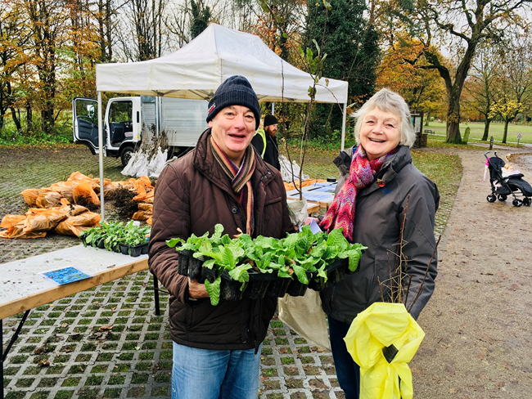 |  | KPI Name | Target | Period 1 | Baseline | Status | Trend
 |  | Number of trees planted | 30,000 | 32,055 | N/A |  | -
 |  |  | Trees that are planted as part of scheme or gifted as part of the programme | - | - | - | -

We will develop a strategy so that the Council and its operations are Carbon Neutral by 2030 (PHE03).
Performance Summary
Period 1:
The objectives of this activity are to;
- Develop the strategy for the Council to be Carbon Neutral by 2030.
- Installation of solar panels at Civic Centre.
- Publicly accessible water station.
- Increase of re-cycling rates by accepting pots, trays and tubs.

Current status/ progress of the project
The Cross-Party Group have met on a number of occasions and are working to finalise the scope of the project. A draft cabinet update report has been written, however as the scope has not yet been approved the project is off track.

What is happening going forward
The next meeting is due for the 4th February

Develop and deliver a strategy to eliminate all single use plastic within Council buildings and seek to encourage the elimination of single use plastics by our residents and businesses (PHE04).
Performance Summary
Period 1:
The Council is seeking to develop its strategy to eliminate all single use plastics.

Current status/ progress of the project
- A strategy has been agreed and the Council have pledged to provide 50 water fountains across the borough over the next 5 to 10 years with ‘Refill’;
- We have not started with the promotion of the reduction of SUPs;

What is happening going forward
- A plan is being developed to undertake an audit of the council’s use of single use plastics.

Deliver the actions identified in the Borough's Air Quality Action Plan (PHE05).
Performance Summary
Period 1:
Current status/ progress of the project
- The cycle to work scheme is still being offered;
- Traffic Light Sequencing – The council has met with Lancashire County Council (LCC), however they have resource and acknowledged that there is further work to be done to optimise traffic light sequencing to keep traffic flowing and help improve the air quality in South Ribble, the Council are seeking a plan/timescale from the LCC;
- Taxi EVR points – a contractor has been chosen to deliver this project.

Potential impacts on success
- Anti- Idling Campaign – this project was underway before Christmas, however due to lack of resources we have not been able to complete the educational phase of the campaign and the enforcement has not started. The resource issue has now been addressed and a Climate Change officer is due to be recruited in January which will seek to bring the plan back on track.

What is happening going forward
- The provision of secure cycle storage at Moss Side Depot will be completed in the next financial year due to the budget constraints.
- Recruitment of Climate Change Officer, January 2020.

 | We will develop ways to ensure our parks and existing cherished local open spaces can be protected (PHE09).
Performance Summary
Period 1:
This activity was established to protect three of our parks and existing open spaces in perpetuity via 'Fields in Trust' model.

Current status/ progress of the project
- Kingsfold Drive Playing Field Penwortham, The Holme Playing Field Bamber Bridge and Tardy Gate Playing Field Lostock Hall have all been submitted for Protected Field Status via the Fields in Trust
Going Forward:
- We are currently awaiting confirmation of protected status from the Fields in Trust.
 |  | KPI Name | Target | Period 1 | Baseline | Status | Trend
 |  | Number of green spaces protected as ‘Fields in Trust’ | 3 | N/A | 0 |  | -
 |  |  | 3 separate areas/fields are protected | Applications submitted | - | - | -

Review the projects listed in the City Deal Business and Delivery Plan 2017- 20, and identify priorities and commence delivery (PHE14).
Performance Summary
Period 1:
The focus of the activity has been to complete a review of the projects as part of City Deal. A report is going to Cabinet on January 2020 that seeks to support a homes England application for £60m to help reduce the projected deficit.

Going Forward:
A final decision as to the Council’s involvement with City Deal will not be taken until late spring early summer 2020.

